L17: Preparation Assignment

Name:_________________________________________
Directions: Please fill in Part Ι as you study the Reading Assignment. Be sure it is completed before you attend Group Preparation. You will complete Part II of this document with your group.
Part I:
- When given a sample, what is the formula for the point estimate ($\hat{p }$) for a population proportion? Explain which each variable stands for in your formula.

$\hat{p}=\frac{x}{n}$, x=number of successes, n=number of trials

- What is the formula for the one-proportion confidence interval for one proportion?

$$\hat{p}±z^{*}\sqrt{\frac{\hat{p}(1-\hat{p})}{n}}$$

- What is the condition required to build the one-proportion confidence interval above?

n$\hat{p}$ ≥ 10
n(1-$\hat{p}$) ≥ 10

- If no prior estimate for the population proportion p is available what is the sample size formula to get the needed sample based on desired margin of error? Explain what each variable stands for in your formula.

$$n={\left(\frac{z^{*}}{2m}\right)}^{2}$$

- What is the test statistic for a hypothesis test regarding the population proportion?
$$z=\frac{\hat{p}-p}{\sqrt{\frac{p(1-p)}{n}}}$$
- What are the conditions that need to be satisfied so the sample size is large enough that the Central Limit Theorem suggests the sample proportion, $\hat{p}$is approximately normal?

np ≥ 10
n(1-p) ≥ 10
Part II: You will complete Part II with your group at Group Preparation
- Confidence Interval – In an October 2008 poll, 684 of 1006 randomly selected college students reported that they had been involved in an automobile accident with in the last 5 years.

  - Find the proportion of those surveyed who have been in an automobile accident in the last 5 years.
$$\hat{p}=\frac{x}{n}=\frac{684}{1006}=0.6799$$

  - Check requirements in constructing a confidence interval for this data.
n$\hat{p}$ ≥ 10 1006*.6799 ≥ 10 683.9794 ≥ 10
n(1-$\hat{p}$) ≥ 10 1006(1-.6799) ≥ 10 322.0206 ≥ 10
The requirements are met.
  - Determine the margin of error for a 95% confidence interval based on these data.

$$1.96×\sqrt{\frac{\hat{p}(1-\hat{p})}{n}}=1.96×\sqrt{\frac{0.6799(1-0.6799)}{1006}}=0.0288$$
  - Construct and interpret the 95% confidence interval for the proportion of those who have been involved in an automobile accident in the last 5 years.

$$\hat{p}±margin of error→0.6799±0.0288→(0.6511, 0.7087)$$
We are 95% confident that the true population proportion, p, is between 0.6511 and 0.7087.

  - How many college students should you survey if you want a 95% confidence interval with a margin of error of no more than 0.015.

$$n={\left(\frac{z^{*}}{2m}\right)}^{2}={\left(\frac{1.96}{2×0.015}\right)}^{2}=4268.44→4269$$

- Hypothesis Test – Now you are interested in testing a claim that over 60% of all students have been in a car accident within the last 5 years. Use the same information as above and use a level of significance of α=0.05.

  - State the null and alternative hypotheses

H₀: p = 0.60
H_{a}: p > 0.60

  - Compute the Test Statistic

$$z=\frac{0.6799-0.60}{\sqrt{\frac{0.60(1-0.60)}{1006}}}=5.173$$

  - Determine P-Value based on Test Statistic. Sketch your P-value on the normal distribution curve with the Test statistic labeled.

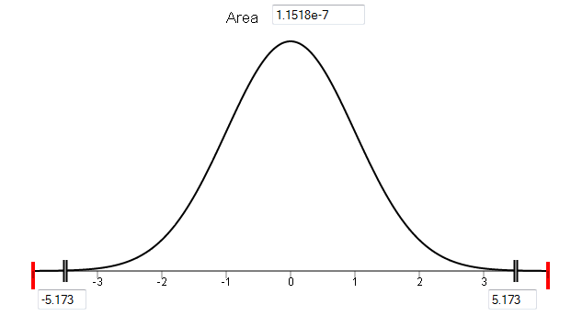 p is close to 0 (p=1.15*10⁻⁷)

  - What decision do you make about the null hypothesis?

We reject the null hypothesis

  - State your conclusions.
We have sufficient evidence to conclude that the true proportion of students that have been in a car accident within the last 5 years is greater than 0.60.

